Journal of Geology & Earth Science

About the Journal:
The Journal of Geology & Earth Science is an international, peer-reviewed, open-access journal dedicated to publishing high-quality research that advances the understanding of Earth systems, geological processes, environmental interactions, and sustainable resource management. The journal serves as a multidisciplinary platform for researchers, academicians, industry professionals, and policymakers to disseminate original research, reviews, short communications, technical notes, and case studies covering both fundamental and applied aspects of geology and Earth sciences.
The journal welcomes innovative contributions that enhance scientific knowledge, promote sustainable environmental practices, and support technological advancements in Earth science research. Emphasis is placed on interdisciplinary studies that integrate geological, environmental, geophysical, geochemical, ecological, and engineering perspectives to address contemporary global challenges.

Latest News:
New Research Warns Current Coastal Hazard Assessments Underestimate Sea-Level Rise:-
A 2026 study published in Nature reported that many coastal hazard assessments have underestimated global sea-level rise because they relied on geoid models rather than direct sea-level measurements. The findings have significant implications for coastal geology, marine ecosystems, environmental sustainability, and climate adaptation planning worldwide.
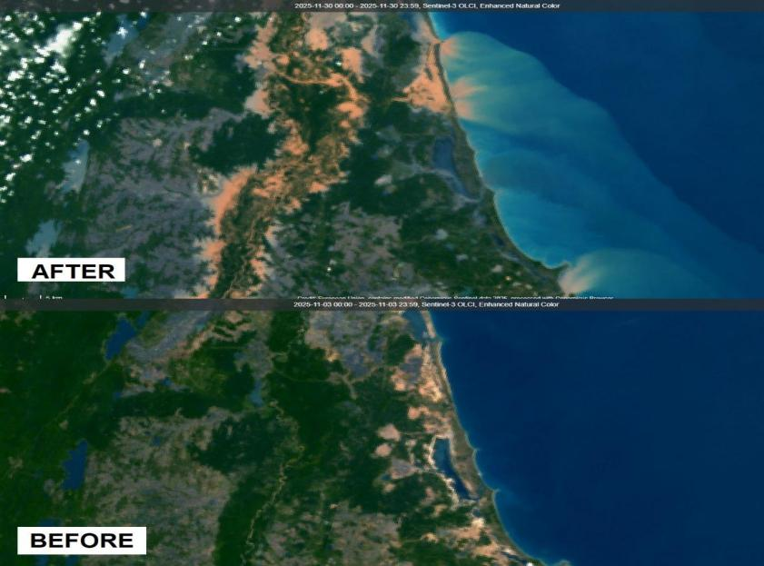

NASA–ISRO NISAR Satellite Delivers New Earth Surface Monitoring Data:-
The NASA–ISRO Synthetic Aperture Radar (NISAR) mission entered full science operations in 2026, providing unprecedented radar observations of earthquakes, landslides, glaciers, forests, groundwater depletion, soil moisture, and land subsidence. Scientists are using NISAR data to improve geological hazard monitoring, hydrogeology studies, and environmental sustainability research.

Global Warming Projected to Reach the 1.5°C Threshold Around 2030:-
An international team of scientists reported that human-induced global warming is likely to reach the 1.5°C threshold by around 2030 if greenhouse gas emissions continue at current rates. The study highlights accelerating climate risks, including more frequent heatwaves, droughts, rising sea levels, ecosystem degradation, and geological hazards. The findings reinforce the importance of interdisciplinary Earth science research in climate resilience, environmental sustainability, and natural resource management.
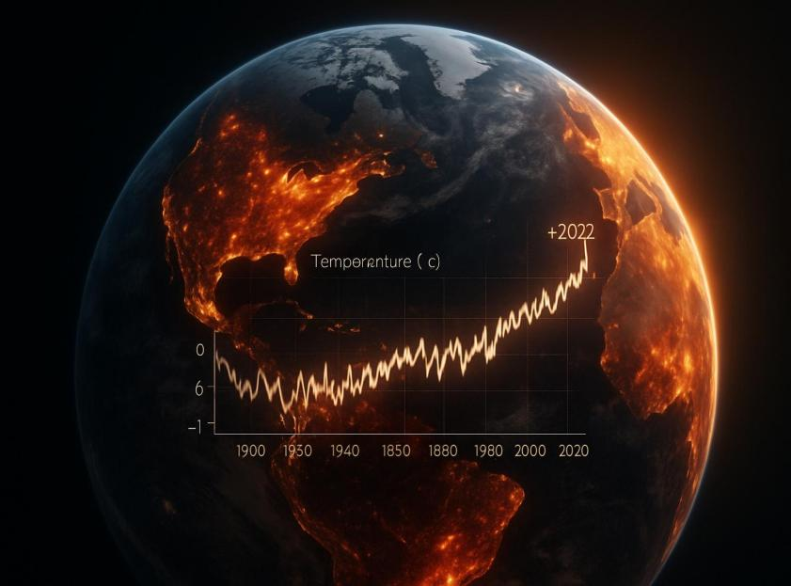

Artificial Intelligence Emerges as a Transformative Tool in Earth Science Research:-
Recent research demonstrates that Earth Science Foundation Models powered by artificial intelligence are transforming geoscience by integrating geological, geophysical, geochemical, hydrological, atmospheric, and ecological datasets into unified analytical frameworks. These AI models are accelerating geological mapping, natural hazard prediction, climate analysis, mineral exploration, and environmental monitoring, representing one of the most significant technological advances in Earth science research.
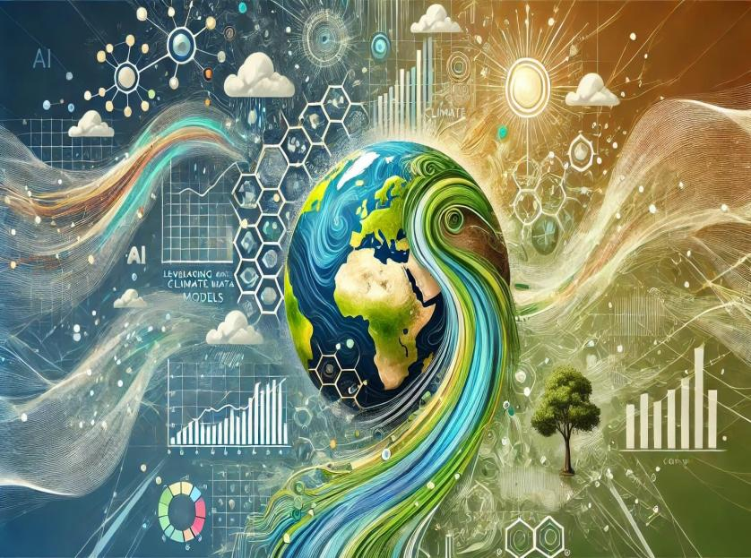

Global Scientific Community Calls for Stronger Climate and Environmental Action:-
Throughout 2026, scientists have emphasized that increasing wildfires, prolonged droughts, ecosystem degradation, and accelerating environmental change highlight the urgent need for stronger global collaboration in Earth science research. Experts stress that integrating geology, climatology, ecology, hydrology, and environmental sciences is essential for improving disaster preparedness, sustainable resource management, and long-term environmental resilience.

Scientific Topics:

- Environmental Geosciences:-
It examines the interactions between Earth's geological processes and the environment. It focuses on natural resources, environmental hazards, pollution, and sustainable ecosystem management. The field supports informed decision-making for environmental protection and long-term sustainability.
- Geotechnical Engineering:-
Geotechnical Engineering focuses on the behavior of soil and rock in the design and construction of foundations, tunnels, slopes, and other infrastructure. It applies geological and engineering principles to assess ground stability and minimize geotechnical risks. The field plays a vital role in ensuring the safety, durability, and sustainability of civil engineering projects.
- Geophysics & Geochemistry:-
Geophysics & Geochemistry investigates the physical properties and chemical composition of the Earth to understand its structure, processes, and evolution. It combines geophysical techniques with geochemical analyses to study rocks, minerals, groundwater, and Earth's interior. The field supports resource exploration, environmental assessment, and hazard monitoring.
- Remote sensing and GIS:-
Utilizes satellite, aerial, and spatial data to observe, analyze, and manage Earth's surface and natural resources. It enables accurate mapping, environmental monitoring, and geological investigations through advanced geospatial technologies. The field supports disaster management, land-use planning, and sustainable resource management.
- Oceanography & Marine geology:-
Explores the Earth's oceans, seafloor, and coastal environments to understand marine geological processes and ocean dynamics. It investigates seafloor sediments, plate tectonics, marine resources, and coastal evolution. The field contributes to environmental conservation, sustainable resource management, and the assessment of marine geological hazards.
6. Igneous & Metamorphic Petrology:-
Examines the origin, composition, texture, and evolution of igneous and metamorphic rocks formed through magmatic activity and metamorphic processes. It provides insights into Earth's crustal development, tectonic history, and mineral formation. The field supports geological mapping, resource exploration, and understanding of Earth's dynamic processes.
7. Environmental Sustainability:-
Focuses on the responsible management of natural resources to protect ecosystems and ensure long-term environmental health. It addresses challenges such as climate change, pollution, biodiversity conservation, and sustainable development. The field promotes scientific solutions that balance environmental protection with social and economic growth.
8. Structural Geology & Rock Mechanics:-
Studies the deformation, structure, and mechanical behavior of rocks within the Earth's crust. It examines faults, folds, fractures, and rock strength to understand geological processes and ground stability. The field supports infrastructure development, mining, tunneling, and geological hazard assessment.
9. Climatology and Meteorology:-
Studies the Earth's climate, atmosphere, and weather systems to understand environmental and atmospheric processes. It examines climate variability, weather patterns, and the impacts of climate change on natural and human systems. The field supports weather forecasting, climate adaptation, disaster preparedness, and sustainable environmental management.
10. Seismology
Studies earthquakes and the propagation of seismic waves through the Earth's interior to understand its structure and dynamics. It investigates the causes, characteristics, and impacts of seismic activity. The field supports earthquake hazard assessment, risk mitigation, and disaster preparedness.
11. Bio-Geochemistry:-
Examines the interactions between biological, geological, and chemical processes within Earth's ecosystems. It investigates the cycling of elements and nutrients through soil, water, atmosphere, and living organisms. The field contributes to understanding environmental change, ecosystem functioning, and sustainable resource management.
12. Paleoecology:-
Studies ancient ecosystems and the interactions between past organisms and their environments through the fossil record. It reconstructs historical climates, biodiversity, and environmental changes over geological time. The field provides valuable insights into Earth's evolutionary history and future environmental trends.
13. Geoarchaeology & Forensic Geology:-
Applies geological principles and techniques to archaeological investigations and forensic science. It analyzes soils, sediments, rocks, and minerals to reconstruct past human activities and support criminal investigations. The field provides valuable evidence for cultural heritage research, site interpretation, and forensic analysis.
Editorial in Chief:
Lorraine Tighe
Earth Sciences Solutions, USA
Biography:
Dr. Lorraine Tighe is a geoscientist and thought leader with over 20 years of experience advancing Earth science through innovative mapping technologies. As Director of Earth Sciences Solutions at Esri, she leads national initiatives that integrate geologic, topographic, and natural resource data using GIS and Earth observation tools. With a Ph.D. in Earth Sciences (Physics), an M.Sc. in Remote Sensing, and a B.Sc. in Physics and Geology, Dr. Tighe brings deep scientific expertise to her mission of promoting sustainability through geospatial thinking. She is internationally recognized for her expertise in Synthetic Aperture Radar (SAR), 3D terrain modeling, and the application of GIS in open science. Dr. Tighe is co-editor of Addressing Earth’s Challenges: GIS for Earth Scientists and a contributing author to the ASPRS DEM User’s Manual. Her work empowers geologists, researchers, and policymakers to better understand and manage Earth’s dynamic systems through cutting-edge geospatial solutions.
6 Articles are attached herewith….

